- Title of proposed idea/innovation
AI-Powered Digital Twin & Predictive Maintenance System for MSMEs

- whether the idea involves use of existing intellectual property or not, give brief detail there of
No, there is no registered IP under this idea.

- Briefly explain newness/uniqueness of the innovation
This innovation brings affordable Industry 4.0 transformation to MSMEs by enabling predictive maintenance without replacing existing machines. It uses a plug-and-play IoT sensor kit to retrofit legacy equipment and creates a digital twin that visualizes machine health in real time. A pre-trained AI model analyses sensor data (vibration, temperature, etc.) to detect faults early and prevent breakdowns. Unlike enterprise solutions, it is designed for low-resource environments, is cost-effective, and includes multilingual dashboards and voice/SMS alerts to ensure accessibility in rural and semi-urban areas. Its simplicity, scalability, and compatibility with any machine make it unique for widespread MSME adoption.

- Concept & Objective
Concept:
In India, a large percentage of MSMEs still rely on traditional or semi-automated machinery without real-time monitoring, diagnostics, or analytics capabilities. This leads to frequent breakdowns, production halts, and unplanned maintenance, causing losses in time and revenue. Retrofitting such legacy machinery with smart technologies is cost-prohibitive for most small enterprises.
The concept of a digital twin—a virtual replica of a physical system—offers a powerful Industry 4.0 solution. It enables real-time data collection, visualization, and simulation of machine behaviour, improving predictive maintenance and operational decision-making. This project proposes a plug-and-play digital twin system using low-cost sensors (vibration, temperature, current) integrated with a machine learning engine to predict and prevent equipment failures.
The system is designed to be affordable, language-localized, and scalable, allowing MSMEs to monitor their operations through a simple dashboard and receive alerts via SMS or voice in local languages. Unlike enterprise-level solutions, this approach is specifically tailored for resource-constrained environments in rural or semi-urban industrial setups.

Objective:
- To retrofit existing MSME machines with sensor kits enabling real-time performance monitoring.
- To develop an AI/ML-based predictive model for early fault detection and anomaly analysis.
- To simulate a digital twin of machines that can visualize operational health and downtime risk.
- To reduce unplanned downtime, extend machine lifespan, and optimize maintenance cycles.
- To provide a user-friendly, low-cost dashboard accessible via mobile or PC in regional languages.
- To empower MSMEs with tools that align with Industry 4.0 goals without expensive overhaul.

- Specify the potential areas of application in industry/market in brief
  - Manufacturing Industries:
Textile, automotive components, plastic moulding, metal fabrication, and machinery shops, where equipment downtime directly affects productivity.
  - Food & Agro-Processing Units:
Facilities using continuous packaging, grinding, mixing, or chilling machines can benefit from predictive fault detection.
  - Pharmaceutical & Chemical Plants:
Monitoring of sensitive equipment like mixers, pumps, or reactors to ensure compliance, quality, and safety.
  - Tool & Die Workshops / Engineering MSMEs:
Precision equipment downtime affects project delivery; predictive maintenance helps avoid delays.
  - Small-Scale Factories in Rural and Tier-2/3 Areas:
Affordable retrofit option for regions where replacing old equipment is not financially feasible.
  - OEM Vendors and Maintenance Service Providers:
Can integrate this as a bundled offering with legacy equipment support services.
  - Industrial Training Institutes / Skill Centers:
To train workers and students on smart manufacturing systems and real-time diagnostics.

- Briefly provide the market data for the potential idea/ innovation
India has over 6.3 crore MSMEs, with more than 80% lacking digital diagnostics or predictive maintenance systems. Machine breakdowns and unplanned downtimes account for 15–25% of productivity losses in small manufacturing units. The global predictive maintenance market is projected to reach USD 18.6 billion by 2027, growing at a CAGR of 28.8%, with significant untapped potential in developing economies like India.
This solution is particularly suited for the Tier-2/Tier-3 MSME market, where affordable, retrofit-based smart solutions are urgently needed. With government support under Make in India, Digital MSME, and Smart Manufacturing initiatives, this product has a strong policy and funding ecosystem to scale nationally. It can also be productized into a subscription-based SaaS tool or hardware kit, opening revenue opportunities for deployment partners, OEMs, and industrial associations.

- Name and details of Mentors
Name: N Jayasri, Assistant Professor, MLR Institute of Technology

- Experience and Qualification of Mentors
Experience: 15 years
Qualification: M.Tech CSE

- Contact Details of Mentors
Mail: jayasree@mlrit.ac.in
Phno: 9030843336

- Current Development Status of innovation
Working on MVP architecture.

- Expected time of completion of idea
12 Months

- Intro and Literature of the Proposal:
This project introduces a low-cost, AI-powered digital twin platform tailored for MSMEs. Most small and medium enterprises in India use legacy machinery with no real-time fault detection or operational monitoring. By leveraging IoT sensors (vibration, temperature, current), this system enables data-driven predictive maintenance, minimizing unexpected breakdowns and maximizing productivity. Literature supports the effectiveness of digital twins and ML models in improving uptime and operational intelligence, especially when localized for resource-constrained settings.

- Outcomes of Literature Review:
- Predictive maintenance improves machine uptime by 25-40%.
- Digital twins are widely adopted in large industries but rarely accessible for MSMEs.
- Low-cost sensors and open-source AI models make digital transformation feasible for small units.

- Key Findings – In Terms of Problems:
- Unplanned breakdowns and production halts.
- No machine visibility or analytics in most MSMEs.
- High cost and complexity of commercial Industry 4.0 tools.

- Key Findings – With Respect to Solutions:
- IoT retrofitting enables affordable machine monitoring.
- Predictive algorithms based on sensor data provide early fault alerts.
- Digital dashboards improve awareness and decision-making.

- Please give activity-wise break-up as mentioned below

Category | Component / Item | Cost (₹)
Hardware Costs | NVIDIA Jetson Xavier NX (16GB) | 70,000
 | Bosch BME688 (Temp/Humidity/VOC) | 11,000
 | Dust/PM2.5 Sensor | 6,000
 | FLIR Lepton 3.5 | 25,000
 | Industrial Vibration Sensor | 18,000
 | Tri-Axis Vibration Sensor (MEMS) | 22,000
 | Hall Effect Current Sensors | 9,000
 | Sony IMX477 HQ Camera + Wide Lens | 10,000
 | 10” Capacitive Industrial Touchscreen | 12,000
 | ESP32 Dual Band + SIM7600 LTE | 8,500
 | Industrial Wi-Fi + LTE Failover Router | 12,000
 | Smart 12V/24V Li-ion Battery + BMS | 18,000
 | Smart Buck Converters + Fuse Box | 6,000
 | CNC Aluminium Casing + DIN Rails | 18,000
 | Vibration Mounts + Brackets | 2,000
 | Transparent Sensor Housing + Vent Grill | 1,500
 | High RPM Cooling Fan + Siren + Beacon Light | 10,500
 | NVMe SSD or Industrial SD Card | 3,000
 | USB Logic Analyzer + Multimeter | 7,000
 | Connectors, PCB, Cables, Heat Shrink, Relays | 6,500
Software Development & AI | Predictive Model | 1,50,000
 | ROS2 Integration with Sensors/Actuators | 50,000
 | Biometric Authentication System Integration | 30,000
 | Realtime Firebase + Cloud Logging + API Hosting | 30,000
 | Interactive Web Dashboard (Operator View + Admin Analytics) | 40,000
 | Software Licenses & Tools | 20,000
Prototyping & Testing | Prototype Assembly | 80,000
 | Pilot Testing | 1,00,000
 | Calibration Equipment | 60,000
TOTAL |  | 10,20,000

- Main Problem Being Addressed in the Project
Main Problem Being Addressed:
A majority of Indian MSMEs operate using legacy or semi-automated machines that lack real-time monitoring and diagnostic capabilities. These units often suffer from unplanned equipment breakdowns, resulting in costly downtime, missed delivery deadlines, production losses, and maintenance inefficiencies. MSME owners have limited technical skills and financial bandwidth to invest in high-end industrial automation solutions. The lack of affordable, user-friendly systems for machine health monitoring and predictive maintenance keeps these businesses vulnerable to operational disruptions. There is a critical need for a low-cost, plug-and-play solution that enables early fault detection and improves productivity, especially in semi-urban and rural MSME sectors.

- Background for getting the idea?
  - Who is it for?
This solution is designed for small and medium manufacturing enterprises (MSMEs) that rely on legacy machinery and lack real-time diagnostics and predictive maintenance capabilities. It is especially beneficial for MSMEs in rural, tier-2, and tier-3 cities, where cost and accessibility are major barriers to technology adoption.
  - What will it do?
It will enable MSMEs to monitor their machine health using a digital twin dashboard powered by real-time sensor data and AI-based predictive models. The system can detect early signs of mechanical faults, provide timely alerts, and help businesses schedule proactive maintenance, thus reducing downtime and improving overall productivity.
- Plug-and-Play Retrofit Design: No need to replace existing machines; works with legacy equipment.
- Multilingual Alert System: Sends alerts via SMS or voice in regional languages, enhancing accessibility.
- Cloud + Edge Integration: Combines real-time sensor data with ML models running on low-power edge devices.
- Affordable and Modular: Scalable across machine types and sectors at a low upfront cost.
- Custom Digital Twin Dashboard: Visual representation of machine behaviour for easy interpretation by factory workers and owners.
These features make it an inclusive and scalable Industry 4.0 tool for MSMEs.

- How simple or complex will the idea’s execution or implementation be? What are the risk factors involved in executing the idea?
Execution Complexity:
The solution is moderately complex but manageable within 6 months for a working MVP. The hardware involves integrating low-cost sensors (temperature, vibration, current) with microcontrollers (Arduino/Raspberry Pi). On the software side, predictive models can be built using Python libraries like Scikit-learn and deployed via FastAPI or Streamlit. The system is modular, scalable, and designed for non-disruptive retrofitting to existing machinery, making implementation practical in MSME environments.
Risk Factors:
- Hardware Compatibility: Different types of machines may require different sensor calibration and mechanical mounts.
- Data Collection Challenges: Initial lack of labelled fault data may affect early ML model accuracy.
- Adoption Resistance: MSMEs with low tech literacy may hesitate to trust or use the system.
- Power/Connectivity Issues: Remote MSMEs may have unreliable internet/power, affect cloud-syncing or alert systems.
- Sensor Durability: Low-cost sensors may wear out or fail in harsh industrial environments unless properly protected.

- How soon could the idea be put into operation? (TRL of prototype)
12 Months. (Technology Readiness Level: TRL 5–6 expected post field trials)

- How much investment would you need for prototyping of the Idea?
50-60% of the Total Idea of the Project

  - How do you intend to protect your idea (i.e. your intellectual property or IP)? Status of IPR (If any)
The idea will be filed for Intellectual Property Rights (IPR) after MVP validation and real-world pilot testing.

  - Related Background.
The concept of digital twins originated in high-end industries such as aerospace and large-scale manufacturing. Tools like Siemens MindSphere and GE Predix are examples of industrial digital twin platforms used for enterprise-level systems, but they are neither affordable nor adaptable for small-scale operations in India.
Academic research in the area of predictive maintenance has focused on machine learning models such as decision trees, support vector machines (SVM), and recurrent neural networks (RNNs) to detect failures based on sensor data. However, these are largely theoretical or implemented in large-scale factory settings.
Most existing platforms do not offer localized, affordable, and plug-and-play predictive maintenance tailored to the Indian MSME ecosystem. This project draws upon open-source hardware, cloud technologies, and AI algorithms, but adapts and integrates them into a low-cost, user-friendly product built for semi-urban industries with minimal digital infrastructure.
The work is inspired by the principles of smart manufacturing, edge AI, and condition-based monitoring and aims to fill the technological void that prevents MSMEs from entering the Industry 4.0 era.

- How is this project made and used?
This project integrates low-cost hardware, machine learning algorithms, and a digital dashboard to build a real-time digital twin of MSME machinery. It enables predictive maintenance through fault detection using sensor data, reducing unplanned downtime and boosting productivity.

Technical Workflow:

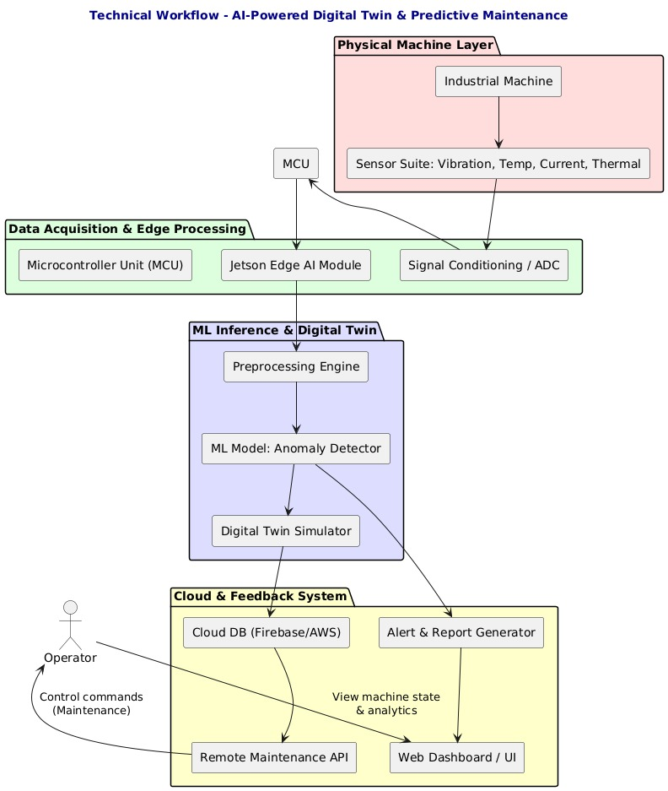

- Sensor Integration (Data Collection):
IoT sensors (e.g., vibration, temperature, current) are mounted on existing machines. These sensors are connected to a microcontroller (Arduino/Raspberry Pi), which continuously collects live machine data.
- Data Transmission:
Sensor data is transmitted via serial/USB or Wi-Fi modules to a central local device or cloud server for logging and analysis. MQTT or HTTP APIs can be used depending on connectivity.
- Preprocessing & Feature Engineering:
Data is filtered to remove noise. Key statistical features like mean vibration level, rate of temperature change, or current fluctuation are extracted for model input.
- ML Model Development (Model Training):
Using past labelled data (machine status logs), a supervised learning model—such as Random Forest, Isolation Forest, or SVM—is trained to detect early signs of fault or abnormal behaviour.
- Model Deployment:
The trained ML model is deployed locally on a Raspberry Pi or hosted on the cloud. It continuously evaluates live sensor input and flags potential failures based on learned thresholds and anomaly scores.
- Digital Twin Interface (Visualization):
A web-based dashboard (Streamlit or React frontend) visualizes the machine's real-time operational status. The UI shows alerts, maintenance predictions, and sensor readings in graphical form.
- Alert System & Feedback Loop:
If abnormalities are detected, SMS or voice alerts are triggered using Twilio/Bhashini API (regional language supported). Maintenance recommendations are logged for future training.

- Control Circuit:

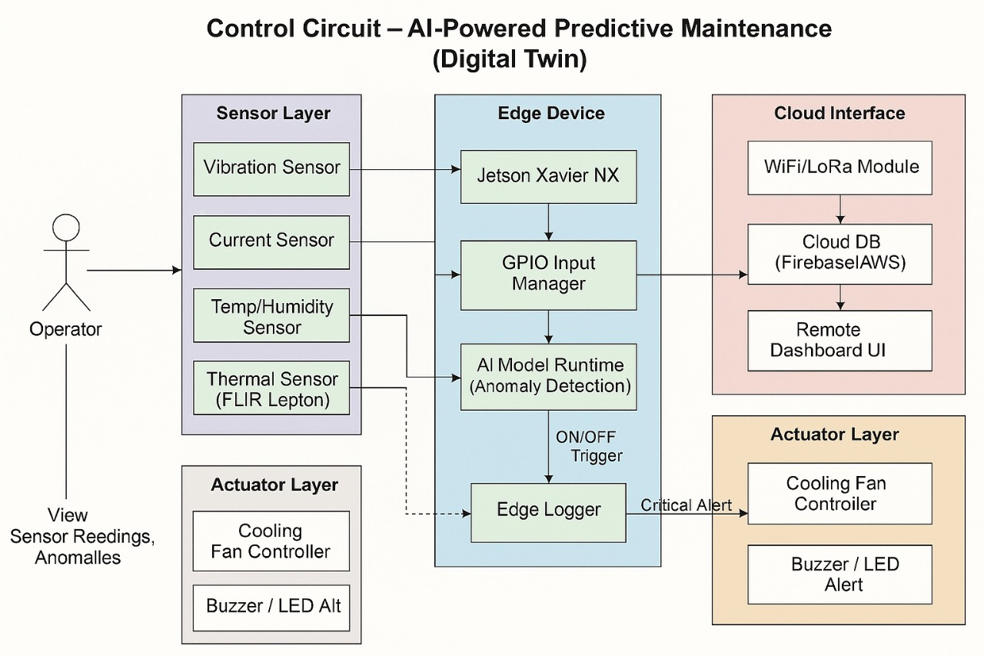

- Summary of the idea.
This project introduces an affordable, plug-and-play AI-powered digital twin system that retrofits existing MSME machinery with IoT sensors to enable real-time monitoring and predictive maintenance. The system uses temperature, vibration, and current sensors to track machine health, while a machine learning model analyses data to forecast faults before they occur. The visual dashboard, accessible in local languages, simulates machine behaviour and provides proactive maintenance alerts through SMS or voice. Designed specifically for small-scale industries in rural and semi-urban areas, this solution helps reduce downtime, extend machine life, and eliminate the need for costly overhauls or enterprise-level automation systems. It brings Industry 4.0 capabilities within reach of every MSME.

